

Daffodil International University

Department of Software Engineering

Fall 2016 | | Level 1 Term 3

**Course Name:** Software Engineering Project (Using C) (**SWE-231**)

**Course Teacher**: **Mr. Khalid Been Badruzzaman Biplob**

Submitted by:

**Md Asrafuzzaman**

ID: **161-35-1607**

Section: **F**

Batch: **19th**

**Table Of Index:**

|  |  |  |  |  |
| --- | --- | --- | --- | --- |
| **Serial** | **Chapter** | **Chapter Name** | **Page** | **Content** |
| 1 | Chapter 1 | Introduction | 3-3 | Title |
| Object |
| Contribution |
| 2 | Chapter 2 | Functionality | 4-4 | Functional Option |
| Non-functional Option |
| 3 | Chapter 3 | Use Case Diagram | 5-5 | Use Case Diagram |
| 4 | Chapter 4 | Model | 6-7 | Initial Requirement  Design  Prototyping  Customer Evaluation  Development  Test  Maintain |
| 5 | Chapter 5 | Gantt Chart | 8-8 | Gantt chart |
| 6 | Chapter 6 | Estimation | 9-9 | Estimation |
| 7 | Chapter 7 | Testing | 10-10 | White Box Test |
| Black box Test |
| 8 | Chapter 8 | Output of project | 11-12 | Project Output |
| 9 | Chapter 9 | Code of Project | 13-28 | Coding(Appendix) |

**Chapter 1**

**Introduction:**

**Title:** **Online Bus ticket management system.**

**Object:** Main goal of my project is to buy a bus ticket staying in home by online portal. A lot of time isn’t possible to go out for buying bus ticket. But my project can help those people, who want to save their time. If they want to buy a bus ticket from home, then they can go to the website & apply for a ticket & after doing all the term & condition & after completing the payment the software give him/her a ticket . If people use this Software, they can save his important time.

**Contribution:**

It is an individual project.

I’m a student named, Md Asrafuzzaman, from department of Software Engineering of Daffodil International University.

My ID : 161-35-1607 & Batch: 19th.

I tried hard & soul for this project & overcame !

This credit also goes to my respected teacher Khalid Been Md. Badruzzaman Biplob.

**Chapter 2**

**Functionality:**

**Functional Option:**

* Location.
* Input box.
* Arrival place
* Sit number
* Cash memo form.
* Bill payment option.

**Non-Functional Option:**

* Administrator updating processes quality.
* For user have bill payment processes which fill up user own.

**Chapter 3**

**Use Case Diagram:**



Administrator



User

**Chapter 4**

**Model:**

This project consists the prototype model. This project follows below statement,

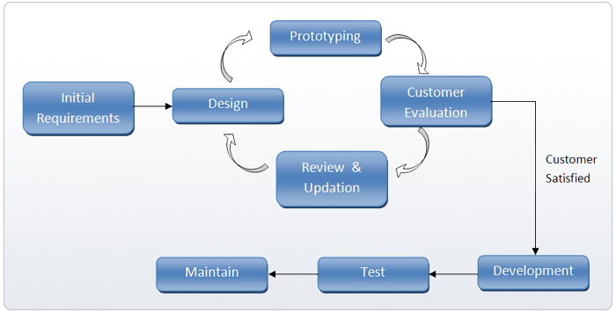

* **Initial Requirement:** All of my requirements were collected by my own & I visited the Kallyanpur Bus stand, Shyamolly bus stand. I also visited the Big bus stand of Dhaka named Gabtali.

I went to Hanif Enterprise main counter, Nabil counter, T R Travels, Rozina Enterprise etc.

* **Design:** The design was completed by my own. I selected the design from web (google) search, I also checked all the online ticket portal & finally was checked by my supervisor **“Khalid Been Badruzzaman Biplob”.** These are:
* **Prototyping:** In this project every task has an evaluation and checked it out by my supervisor as a customer. I had to completed the full coding & I showed the file to my supervisor. And when the supervisor is satisfied then I started to new prototype task. In this evaluation processes I completed my prototype task. Then I joined that prototype in a single main project.
* **Development:** After prototyping I started to develop my project quality.
* **Test:** I completed my project test as 2 testing processes
* White box test.
* Black box test.
* **Maintain:** I can maintain my project. Suppose customer need new facilities or want to to buy more than 1 ticket. Then I can update it very soon. And without code running I can update it.

**Chapter 6**

**Estimation:**

|  |  |
| --- | --- |
| Function | Estimate Loc |
| User interface | 2300 |
| Database management | 6800 |
| Report Generation | 1800 |
| Estimation LOC | 10900 |

Suppose,

Productivity = 3000 LOC/person-month

Development cost=$8000 person-month

Person-month = LOC/productivity

Cost of Software = Development cost*Person-month

Person-month = 10900/3000

= 3.6

Cost of Software = 8000*3.6

= 28800

Cost of Line = cost of Software/LOC

=28800/10900

= 2.64$

**Chapter 7**

**Testing of Project:**

We did test of our project as 2 type

* White Box testing.
* Black Box Testing

**White Box Testing:** It is a testing processes which is test in coding. Which processes completed by me;

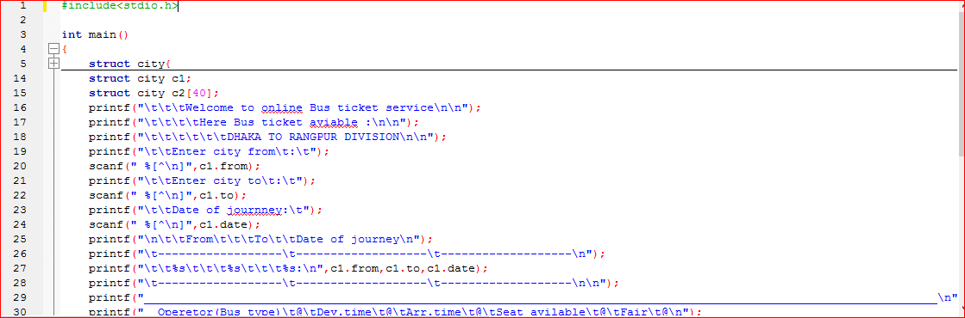

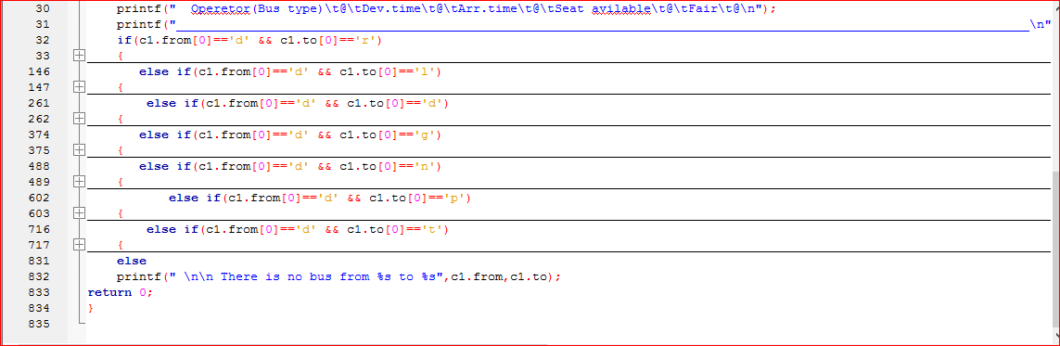

**Black Box Testing:** Which processes are doing output testing this proceses is called “black Box Testing” Which processes completed by me.Given the output of this project in chepter 6.

**Chapter 8**

**Output of Project:**

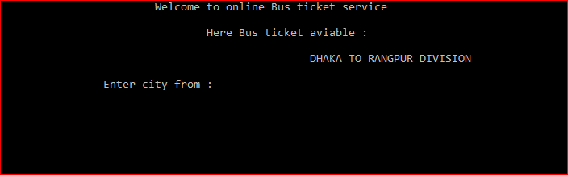

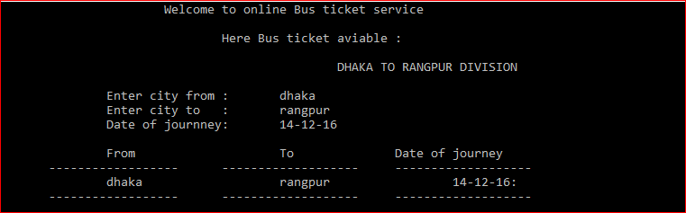

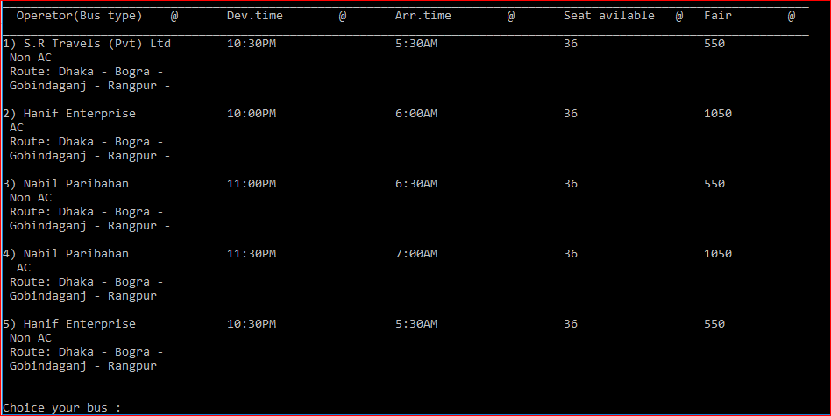

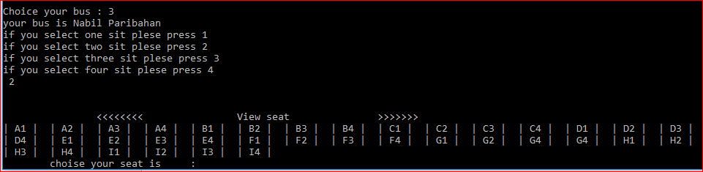

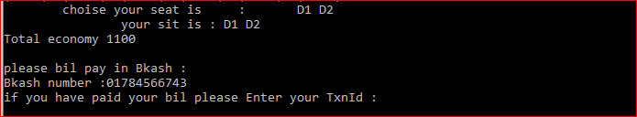

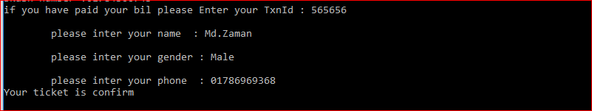 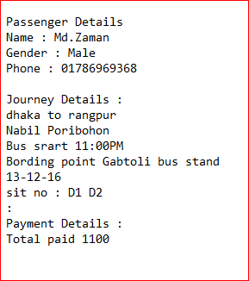

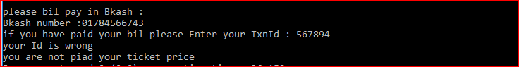

**Chapter 9**

**Coding of Project:**

**#include<stdio.h>**

**int main()**

**{**

**struct city{**

**char from[15];**

**char to[15];**

**char date[15];**

**char sit[40];**

**char name[20];**

**char number[15];**

**char gender[10];**

**};**

**struct city c1;**

**struct city c2[40];**

**printf("\t\t\tWelcome to online Bus ticket service\n\n");**

**printf("\t\t\t\tHere Bus ticket aviable :\n\n");**

**printf("\t\t\t\t\t\tDHAKA TO RANGPUR DIVISION\n\n");**

**printf("\t\tEnter city from\t:\t");**

**scanf(" %[^\n]",c1.from);**

**printf("\t\tEnter city to\t:\t");**

**scanf(" %[^\n]",c1.to);**

**printf("\t\tDate of journney:\t");**

**scanf(" %[^\n]",c1.date);**

**printf("\n\t\tFrom\t\t\tTo\t\tDate of journey\n");**

**printf("\t------------------\t-------------------\t-------------------\n");**

**printf("\t\t%s\t\t\t%s\t\t\t%s:\n",c1.from,c1.to,c1.date);**

**printf("\t------------------\t-------------------\t-------------------\n\n");**

**printf("___________________________________________________________________________________________________________________\n");**

**printf(" Operetor(Bus type)\t@\tDev.time\t@\tArr.time\t@\tSeat avilable\t@\tFair\t@\n");**

**printf("___________________________________________________________________________________________________________________\n");**

**if(c1.from[0]=='d' && c1.to[0]=='r')**

**{**

**printf("1) S.R Travels (Pvt) Ltd\t10:30PM\t\t\t5:30AM\t\t\t36\t\t\t550\n");**

**printf(" Non AC\n Route: Dhaka - Bogra -\n Gobindaganj - Rangpur -\n\n");**

**printf("2) Hanif Enterprise\t\t10:00PM\t\t\t6:00AM\t\t\t36\t\t\t1050\n");**

**printf(" AC\n Route: Dhaka - Bogra -\n Gobindaganj - Rangpur -\n\n");**

**printf("3) Nabil Paribahan\t\t11:00PM\t\t\t6:30AM\t\t\t36\t\t\t550\n");**

**printf(" Non AC\n Route: Dhaka - Bogra -\n Gobindaganj - Rangpur -\n\n");**

**printf("4) Nabil Paribahan\t\t11:30PM\t\t\t7:00AM\t\t\t36\t\t\t1050\n");**

**printf(" AC\n Route: Dhaka - Bogra -\n Gobindaganj - Rangpur \n\n");**

**printf("5) Hanif Enterprise\t\t10:30PM\t\t\t5:30AM\t\t\t36\t\t\t550\n");**

**printf(" Non AC\n Route: Dhaka - Bogra -\n Gobindaganj - Rangpur\n");**

**int i;**

**printf("\n\nChoice your bus : ");**

**int n,m,r;**

**scanf("%d",&n);**

**switch(n){**

**case 1:**

**printf("your bus is S.R Travels (Pvt) Ltd\n");**

**printf("if you select one sit plese press 1\nif you select two sit plese press 2\n");**

**printf("if you select three sit plese press 3\nif you select four sit plese press 4\n ");**

**scanf("%d",&m);**

**r=m*550;**

**break;**

**case 2:**

**printf("your bus is Hanif Enterprise and AC service\n");**

**printf("if you select one sit plese press 1\nif you select two sit plese press 2\n");**

**printf("if you select three sit plese press 3\nif you select four sit plese press 4\n ");**

**scanf("%d",&m);**

**r=m*1050;**

**break;**

**case 3:**

**printf("your bus is Nabil Paribahan\n");**

**printf("if you select one sit plese press 1\nif you select two sit plese press 2\n");**

**printf("if you select three sit plese press 3\nif you select four sit plese press 4\n ");**

**scanf("%d",&m);**

**r=m*550;**

**break;**

**case 4:**

**printf("your bus is Nabil Paribahan and AC service\n");**

**printf("if you select one sit plese press 1\nif you select two sit plese press 2\n");**

**printf("if you select three sit plese press 3\nif you select four sit plese press 4\n ");**

**scanf("%d",&m);**

**r=m*1050;**

**break;**

**case 5:**

**printf("your bus is Hanif Enterprise\n");**

**printf("if you select one sit plese press 1\nif you select two sit plese press 2\n");**

**printf("if you select three sit plese press 3\nif you select four sit plese press 4\n ");**

**scanf("%d",&m);**

**r=m*550;**

**break;**

**}**

**printf("\n\n\t\t<<<<<<<<\t\tView seat\t\t>>>>>>>\n");**

**FILE*fp;**

**fp=fopen("ticket.txt","r");**

**for(i=0;i<36;i++){**

**fscanf(fp," %s",&c2[i].sit);**

**}**

**for(i=0;i<36;i++){**

**printf("| %s |\t",c2[i].sit);**

**}**

**printf("\n\tchoise your seat is\t:\t");**

**scanf(" %[^\n]",&c2[i].sit);**

**printf("\t\tyour sit is : %s\n",c2[i].sit);**

**printf("Total economy %d\n\n",r);**

**fclose(fp);**

**int h;**

**printf("please bil pay in Bkash : \nBkash number :01784566743\n");**

**printf("if you have paid your bil please Enter your TxnId : ");**

**scanf(" %[^\n]",&h);**

**if(h=565656){**

**printf("\n\tplease inter your name : ");**

**scanf(" %[^\n]",c1.name);**

**printf("\n\tplease inter your gender : ");**

**scanf(" %[^\n]",c1.gender);**

**printf("\n\tplease inter your phone : ");**

**scanf(" %[^\n]",c1.number);**

**FILE*fptr;**

**fptr=fopen("zaman.txt","a+");**

**fprintf(fptr,"\n\nPassenger Details\nName : %s\nGender : %s\nPhone : %s\n\n",c1.name,c1.gender,c1.number);**

**fprintf(fptr,"Journey Details :\n");**

**fprintf(fptr,"%s to %s\n",c1.from,c1.to);**

**switch(n){**

**case 1:**

**fprintf(fptr,"S.R Travels \nBus srart 10:30PM\n");**

**fprintf(fptr,"Bording point Gabtoli bus stand\n");**

**break;**

**case 2:**

**fprintf(fptr,"Hanif Enterprise \nBus srart 10:00PM\n");**

**fprintf(fptr,"Bording point Gabtoli bus stand\n");**

**break;**

**case 3:**

**fprintf(fptr,"Nabil Poribohon \nBus srart 11:00PM\n");**

**fprintf(fptr,"Bording point Gabtoli bus stand\n");**

**break;**

**case 4:**

**fprintf(fptr,"Nabil Poribohon\nBus srart 11:30PM\n");**

**fprintf(fptr,"Bording point Gabtoli bus stand\n");**

**break;**

**case 5:**

**fprintf(fptr,"Hanif Enterprise \nBus srart 10:30PM\n");**

**fprintf(fptr,"Bording point Gabtoli bus stand\n");**

**break;**

**}**

**fprintf(fptr,"%s\nsit no : %s\n:",c1.date,c2[i].sit);**

**fprintf(fptr,"\nPayment Details :\n");**

**fprintf(fptr,"Total paid %d",r);**

**printf("your Id is wrong\nYour ticket is confirm\n");**

**fclose(fptr);**

**}**

**else**

**printf("your Id is wrong\nyou are not piad your ticket price");**

**}**

**else if(c1.from[0]=='d' && c1.to[0]=='l')**

**{**

**printf("1) Rozina Enterprise\t\t11:00PM\t\t\t7:00AM\t\t\t30\t\t\t550\n");**

**printf(" Non AC\n Route: Dhaka - Bogra -\n Gobindaganj - Rangpur - \n Lalmonirhat - Tushbh...\n\n");**

**printf("2) Hanif Enterprise\t\t10:00PM\t\t\t6:00AM\t\t\t36\t\t\t1050\n");**

**printf(" AC\n Route: Dhaka - Bogra -\n Gobindaganj - Rangpur - \n Lalmonirhat - Tushbh...\n\n");**

**printf("3) Nabil Paribahan\t\t10:30PM\t\t\t6:00AM\t\t\t36\t\t\t550\n");**

**printf(" Non AC\n Route: Dhaka - Bogra -\n Gobindaganj - Rangpur - \n Lalmonirhat - Tushbh...\n\n");**

**printf("4) Nabil Paribahan\t\t11:00PM\t\t\t6:30AM\t\t\t36\t\t\t1050\n");**

**printf(" AC\n Route: Dhaka - Bogra -\n Gobindaganj - Rangpur - \n Lalmonirhat - Tushbh...\n\n");**

**printf("5) Hanif Enterprise\t\t10:30PM\t\t\t7:00AM\t\t\t36\t\t\t550\n");**

**printf(" Non AC\n Route: Dhaka - Bogra -\n Gobindaganj - Rangpur - \n Lalmonirhat - Tushbh...\n");**

**int i;**

**printf("\n\nChoice your bus : ");**

**int n,m,r;**

**scanf("%d",&n);**

**switch(n){**

**case 1:**

**printf("your bus is Rozina enterprise\n");**

**printf("if you select one sit plese press 1\nif you select two sit plese press 2\n");**

**printf("if you select three sit plese press 3\nif you select four sit plese press 4\n ");**

**scanf("%d",&m);**

**r=m*550;**

**break;**

**case 2:**

**printf("your bus is Hanif Enterprise and AC service\n");**

**printf("if you select one sit plese press 1\nif you select two sit plese press 2\n");**

**printf("if you select three sit plese press 3\nif you select four sit plese press 4\n ");**

**scanf("%d",&m);**

**r=m*1050;**

**break;**

**case 3:**

**printf("your bus is Nabil Enterprise\n");**

**printf("if you select one sit plese press 1\nif you select two sit plese press 2\n");**

**printf("if you select three sit plese press 3\nif you select four sit plese press 4\n ");**

**scanf("%d",&m);**

**r=m*550;**

**break;**

**case 4:**

**printf("your bus is Nabil Enterprise and AC service\n");**

**printf("if you select one sit plese press 1\nif you select two sit plese press 2\n");**

**printf("if you select three sit plese press 3\nif you select four sit plese press 4\n ");**

**scanf("%d",&m);**

**r= m*1050;**

**break;**

**case 5:**

**printf("your bus is Hanif Enterprise\n");**

**printf("if you select one sit plese press 1\nif you select two sit plese press 2\n");**

**printf("if you select three sit plese press 3\nif you select four sit plese press 4\n ");**

**scanf("%d",&m);**

**r=m*550;**

**break;**

**}**

**printf("\n\n\t\t<<<<<<<<\t\tView seat\t\t>>>>>>>\n");**

**FILE *fp;**

**fp=fopen("ticket.txt","r");**

**for(i=0;i<36;i++){**

**fscanf(fp," %s",&c2[i].sit);**

**}**

**for(i=0;i<36;i++){**

**printf("| %s |\t",c2[i].sit);**

**}**

**printf("\n\tchoise your seat is\t:\t");**

**scanf(" %[^\n]",&c2[i].sit);**

**printf("\t\tyour sit is : %s\n",c2[i].sit);**

**fclose(fp);**

**printf("Total economy %d",r);**

**int h;**

**printf("please bil pay in Bkash : \nBkash number :01784566743\n");**

**printf("if you have paid your bil please Enter your TxnId : ");**

**scanf(" %[^\n]",&h);**

**if(h=565656){**

**printf("\n\tplease inter your name : ");**

**scanf(" %[^\n]",c1.name);**

**printf("\n\tplease inter your gender : ");**

**scanf(" %[^\n]",c1.gender);**

**printf("\n\tplease inter your phone : ");**

**scanf(" %[^\n]",c1.number);**

**FILE*fptr;**

**fptr=fopen("zaman.txt","a+");**

**fprintf(fptr,"\n\nPassenger Details\nName : %s\nGender : %s\nPhone : %s\n\n",c1.name,c1.gender,c1.number);**

**fprintf(fptr,"Journey Details :\n");**

**fprintf(fptr,"%s to %s\n",c1.from,c1.to);**

**switch(n){**

**case 1:**

**fprintf(fptr,"Rozina enterprise \nBus srart 11:00PM\n");**

**fprintf(fptr,"Bording point Gabtoli bus stand\n");**

**break;**

**case 2:**

**fprintf(fptr,"Hanif Enterprise \nBus srart 10:00PM\n");**

**fprintf(fptr,"Bording point Gabtoli bus stand\n");**

**break;**

**case 3:**

**fprintf(fptr,"Nabil Poribohon \nBus srart 10:30PM\n");**

**fprintf(fptr,"Bording point Gabtoli bus stand\n");**

**break;**

**case 4:**

**fprintf(fptr,"Nabil Poribohon\nBus srart 11:00PM\n");**

**fprintf(fptr,"Bording point Gabtoli bus stand\n");**

**break;**

**case 5:**

**fprintf(fptr,"Hanif Enterprise \nBus srart 10:30PM\n");**

**fprintf(fptr,"Bording point Gabtoli bus stand\n");**

**break;**

**}**

**fprintf(fptr,"%s\nsit no : %s\n:",c1.date,c2[i].sit);**

**fprintf(fptr,"\nPayment Details :\n");**

**fprintf(fptr,"Total paid %d",r);**

**printf("Your ticket is confirm\n");**

**fclose(fptr);**

**}**

**else**

**printf("your Id is wrong\nyou are not piad your ticket price");**

**}**

**else if(c1.from[0]=='d' && c1.to[0]=='d')**

**{**

**printf("1) Nabil Paribahan\t\t10:00PM\t\t\t6:30AM\t\t\t36\t\t\t550\n");**

**printf(" Non AC\n Route: Dhaka -- Dinajpur\n\n");**

**printf("2) Hanif Enterprise\t\t11:00PM\t\t\t6:00AM\t\t\t36\t\t\t1050\n");**

**printf(" AC\n Route: Dhaka -- dinajpur\n\n");**

**printf("3) Ena Transport (Pvt) Ltd\t10:30PM\t\t\t6:00AM\t\t\t36\t\t\t550\n");**

**printf(" Non AC\n Route: Dhaka --Dinajpur\n\n");**

**printf("4) Nabil Paribahan\t\t10:00PM\t\t\t6:30AM\t\t\t36\t\t\t1050\n");**

**printf(" AC\n Route: Dhaka -- Dinajpur\n\n");**

**printf("5) Hanif Enterprise\t\t10:30PM\t\t\t6:30AM\t\t\t36\t\t\t550\n");**

**printf(" Non AC\n Route: Dhaka -- Dinajpur\n");**

**int i;**

**printf("\n\nChoice your bus : ");**

**int n,m,r;**

**scanf("%d",&n);**

**switch(n){**

**case 1:**

**printf("your bus is Nabil Paribahan\n");**

**printf("if you select one sit plese press 1\nif you select two sit plese press 2\n");**

**printf("if you select three sit plese press 3\nif you select four sit plese press 4\n ");**

**scanf("%d",&m);**

**r=m*550;**

**case 2:**

**printf("your bus is Hanif Enterprise and AC service\n");**

**printf("if you select one sit plese press 1\nif you select two sit plese press 2\n");**

**printf("if you select three sit plese press 3\nif you select four sit plese press 4\n ");**

**scanf("%d",&m);**

**r=m*1050;**

**break;**

**case 3:**

**printf("your bus is Ena Transport (Pvt) Ltd\n");**

**printf("if you select one sit plese press 1\nif you select two sit plese press 2\n");**

**printf("if you select three sit plese press 3\nif you select four sit plese press 4\n ");**

**scanf("%d",&m);**

**r=m*550;**

**break;**

**case 4:**

**printf("your bus is Nabil Enterprise and AC service\n");**

**printf("if you select one sit plese press 1\nif you select two sit plese press 2\n");**

**printf("if you select three sit plese press 3\nif you select four sit plese press 4\n ");**

**scanf("%d",&m);**

**r=m*1050;**

**break;**

**case 5:**

**printf("your bus is Hanif Enterprise\n");**

**printf("if you select one sit plese press 1\nif you select two sit plese press 2\n");**

**printf("if you select three sit plese press 3\nif you select four sit plese press 4\n ");**

**scanf("%d",&m);**

**r=m*550;**

**break;**

**}**

**printf("\n\n\t\t<<<<<<<<\t\tView seat\t\t>>>>>>>\n");**

**FILE *fp;**

**fp=fopen("ticket.txt","r");**

**for(i=0;i<36;i++){**

**fscanf(fp," %s",&c2[i].sit);**

**}**

**for(i=0;i<36;i++){**

**printf("| %s |\t",c2[i].sit);**

**}**

**printf("\n\tchoise your seat is\t:\t");**

**scanf(" %[^\n]",&c2[i].sit);**

**printf("\t\tyour sit is : %s\n",c2[i].sit);**

**fclose(fp);**

**printf("Total economy %d",r);**

**int h;**

**printf("please bil pay in Bkash : \nBkash number :01784566743\n");**

**printf("if you have paid your bil please Enter your TxnId : ");**

**scanf(" %[^\n]",&h);**

**if(h=565656){**

**printf("\n\tplease inter your name : ");**

**scanf(" %[^\n]",c1.name);**

**printf("\n\tplease inter your gender : ");**

**scanf(" %[^\n]",c1.gender);**

**printf("\n\tplease inter your phone : ");**

**scanf(" %[^\n]",c1.number);**

**FILE*fptr;**

**fptr=fopen("zaman.txt","a+");**

**fprintf(fptr,"\n\nPassenger Details\nName : %s\nGender : %s\nPhone : %s\n\n",c1.name,c1.gender,c1.number);**

**fprintf(fptr,"Journey Details :\n\n");**

**fprintf(fptr,"%s to %s\n",c1.from,c1.to);**

**switch(n){**

**case 1:**

**fprintf(fptr,"Nabil Paribahan\nBus srart 11:00PM\n");**

**fprintf(fptr,"Bording point Gabtoli bus stand\n");**

**break;**

**case 2:**

**fprintf(fptr," Hanif Enterprise \nBus srart 10:00PM\n");**

**fprintf(fptr,"Bording point Gabtoli bus stand\n");**

**break;**

**case 3:**

**fprintf(fptr,"Ena Transport\nBus srart 10:30PM\n");**

**fprintf(fptr,"Bording point Gabtoli bus stand\n");**

**break;**

**case 4:**

**fprintf(fptr,"Nabil Poribohon\nBus srart 10:00PM\n");**

**fprintf(fptr,"Bording point Gabtoli bus stand\n");**

**break;**

**case 5:**

**fprintf(fptr,"Hanif Enterprise \nBus srart 10:30PM\n");**

**fprintf(fptr,"Bording point Gabtoli bus stand\n");**

**break;**

**}**

**fprintf(fptr,"%s\nsit no : %s\n:",c1.date,c2[i].sit);**

**fprintf(fptr,"\nPayment Details :\n");**

**fprintf(fptr,"Total paid %d",r);**

**printf("Your ticket is confirm\n");**

**fclose(fptr);**

**}**

**else**

**printf("your Id is wrong\nyou are not piad your ticket price\n");**

**}**

**else if(c1.from[0]=='d' && c1.to[0]=='g')**

**{**

**printf("1) S.R Travels (Pvt) Ltd\t\t11:00PM\t\t\t6:00AM\t\t\t36\t\t\t550\n");**

**printf(" Non AC\n Route: Dhaka - Bogra -\n Gaibandha\n\n");**

**printf("2) S.R Travels (Pvt) Ltd\t\t10:30PM\t\t\t6:00AM\t\t\t36\t\t\t1050\n");**

**printf(" AC\n Route: Dhaka - Bogra -\n Gaibandha\n\n");**

**printf("3) Nabil Paribahan\t\t\t10:00PM\t\t\t5:30AM\t\t\t36\t\t\t550\n");**

**printf(" Non AC\n Route: Dhaka - Bogra -\n Gaibandha\n\n");**

**printf("4) Nabil Paribahan\t\t\t11:00PM\t\t\t6:00AM\t\t\t36\t\t\t1050\n");**

**printf(" AC\n Route: Dhaka - Bogra -\n Gaibandha\n\n");**

**printf("5) Hanif Enterprise\t\t\t10:30PM\t\t\t6:30AM\t\t\t36\t\t\t550\n");**

**printf(" Non AC\n Route: Dhaka - Bogra -\n Gaibandha\n");**

**int i;**

**printf("\n\nChoice your bus : ");**

**int n,m,r;**

**scanf("%d",&n);**

**switch(n){**

**case 1:**

**printf("your bus is S.R Travels (Pvt) Ltd\n");**

**printf("if you select one sit plese press 1\nif you select two sit plese press 2\n");**

**printf("if you select three sit plese press 3\nif you select four sit plese press 4\n ");**

**scanf("%d",&m);**

**r=m*550;**

**break;**

**case 2:**

**printf("your bus is S.R Travels (Pvt) Ltd\n");**

**printf("if you select one sit plese press 1\nif you select two sit plese press 2\n");**

**printf("if you select three sit plese press 3\nif you select four sit plese press 4\n ");**

**scanf("%d",&m);**

**r=m*1050;**

**break;**

**case 3:**

**printf("your bus is Nabil Paribahan\n");**

**printf("if you select one sit plese press 1\nif you select two sit plese press 2\n");**

**printf("if you select three sit plese press 3\nif you select four sit plese press 4\n ");**

**scanf("%d",&m);**

**r=m*550;**

**break;**

**case 4:**

**printf("your bus is Nabil Paribahan and AC service\n");**

**printf("if you select one sit plese press 1\nif you select two sit plese press 2\n");**

**printf("if you select three sit plese press 3\nif you select four sit plese press 4\n ");**

**scanf("%d",&m);**

**r=m*1050;**

**break;**

**case 5:**

**printf("your bus is Hanif Enterprise\n");**

**printf("if you select one sit plese press 1\nif you select two sit plese press 2\n");**

**printf("if you select three sit plese press 3\nif you select four sit plese press 4\n ");**

**scanf("%d",&m);**

**r=m*550;**

**break;**

**}**

**printf("\n\n\t\t<<<<<<<<\t\tView seat\t\t>>>>>>>\n");**

**FILE *fp;**

**fp=fopen("ticket.txt","r");**

**for(i=0;i<36;i++){**

**fscanf(fp," %s",&c2[i].sit);**

**}**

**for(i=0;i<36;i++){**

**printf("| %s |\t",c2[i].sit);**

**}**

**printf("\n\tchoise your seat is\t:\t");**

**scanf(" %[^\n]",&c2[i].sit);**

**printf("\t\tyour sit is : %s\n",c2[i].sit);**

**fclose(fp);**

**printf("Total economy %d",r);**

**int h;**

**printf("please bil pay in Bkash : \nBkash number :01784566743\n");**

**printf("if you have paid your bil please Enter your TxnId : ");**

**scanf(" %[^\n]",&h);**

**if(h=565656){**

**printf("\n\tplease inter your name : ");**

**scanf(" %[^\n]",c1.name);**

**printf("\n\tplease inter your gender : ");**

**scanf(" %[^\n]",c1.gender);**

**printf("\n\tplease inter your phone : ");**

**scanf(" %[^\n]",c1.number);**

**FILE*fptr;**

**fptr=fopen("zaman.txt","a+");**

**fprintf(fptr,"\n\nPassenger Details\nName : %s\nGender : %s\nPhone : %s\n\n",c1.name,c1.gender,c1.number);**

**fprintf(fptr,"Journey Details :\n\n");**

**fprintf(fptr,"%s to %s\n",c1.from,c1.to);**

**switch(n){**

**case 1:**

**fprintf(fptr,"S.R Travels \nBus srart 11:00PM\n");**

**fprintf(fptr,"Bording point Gabtoli bus stand\n");**

**break;**

**case 2:**

**fprintf(fptr,"S.R Travels \nBus srart 10:30PM\n");**

**fprintf(fptr,"Bording point Gabtoli bus stand\n");**

**break;**

**case 3:**

**fprintf(fptr,"Nabil Poribohon \nBus srart 10:00PM\n");**

**fprintf(fptr,"Bording point Gabtoli bus stand\n");**

**break;**

**case 4:**

**fprintf(fptr,"Nabil Poribohon\nBus srart 11:00PM\n");**

**fprintf(fptr,"Bording point Gabtoli bus stand\n");**

**break;**

**case 5:**

**fprintf(fptr,"Hanif Enterprise \nBus srart 10:30PM\n");**

**fprintf(fptr,"Bording point Gabtoli bus stand\n");**

**break;**

**}**

**fprintf(fptr,"%s\nsit no %s\n:",c1.date,c2[i].sit);**

**fprintf(fptr,"\nPayment Details :\n");**

**fprintf(fptr,"Total paid %d",r);**

**printf("Your ticket is confirm\n");**

**fclose(fptr);**

**}**

**else**

**printf("your Id is wrong\nyou are not piad your ticket price\n");**

**}**

**else if(c1.from[0]=='d' && c1.to[0]=='n')**

**{**

**printf("1) S.R Travels (Pvt) Ltd\t11:00PM\t\t\t6:00AM\t\t\t36\t\t\t550\n");**

**printf(" Non AC\n Route: Dhaka - Bogra -\n Gobindaganj - Rangpur - \n Nilphamari\n\n");**

**printf("2) Hanif Enterprise\t\t10:30PM\t\t\t6:00AM\t\t\t36\t\t\t1050\n");**

**printf(" AC\n Route: Dhaka - Bogra -\n Gobindaganj - Rangpur - \n Nilphamari\n\n");**

**printf("3) Nabil Paribahan\t\t11:00PM\t\t\t6:00AM\t\t\t36\t\t\t550\n");**

**printf(" Non AC\n Route: Dhaka - Bogra -\n Gobindaganj - Rangpur - \n Nilphamari\n\n");**

**printf("4) Nabil Paribahan\t\t10:00PM\t\t\t6:30AM\t\t\t36\t\t\t1050\n");**

**printf(" AC\n Route: Dhaka - Bogra -\n Gobindaganj - Rangpur - \n Nilphamari\n\n");**

**printf("5) Hanif Enterprise\t\t11:00PM\t\t\t6:00AM\t\t\t36\t\t\t550\n");**

**printf(" Non AC\n Route: Dhaka - Bogra -\n Gobindaganj - Rangpur - \n Nilphamari\n");**

**int i;**

**printf("\n\nChoice your bus : ");**

**int n,m,r;**

**scanf("%d",&n);**

**switch(n){**

**case 1:**

**printf("your bus is S.R Travels (Pvt) Ltd\n");**

**printf("if you select one sit plese press 1\nif you select two sit plese press 2\n");**

**printf("if you select three sit plese press 3\nif you select four sit plese press 4\n ");**

**scanf("%d",&m);**

**r=m*550;**

**break;**

**case 2:**

**printf("your bus is Hanif Enterprise and AC service\n");**

**printf("if you select one sit plese press 1\nif you select two sit plese press 2\n");**

**printf("if you select three sit plese press 3\nif you select four sit plese press 4\n ");**

**scanf("%d",&m);**

**r=m*1050;**

**break;**

**case 3:**

**printf("your bus is Nabil Paribahan\n");**

**printf("if you select one sit plese press 1\nif you select two sit plese press 2\n");**

**printf("if you select three sit plese press 3\nif you select four sit plese press 4\n ");**

**scanf("%d",&m);**

**r=m*550;**

**break;**

**case 4:**

**printf("your bus is Nabil Paribahan and AC service\n");**

**printf("if you select one sit plese press 1\nif you select two sit plese press 2\n");**

**printf("if you select three sit plese press 3\nif you select four sit plese press 4\n ");**

**scanf("%d",&m);**

**r=m*1050;**

**break;**

**case 5:**

**printf("your bus is Hanif Enterprise\n");**

**printf("if you select one sit plese press 1\nif you select two sit plese press 2\n");**

**printf("if you select three sit plese press 3\nif you select four sit plese press 4\n ");**

**scanf("%d",&m);**

**r=m*550;**

**break;**

**}**

**printf("\n\n\t\t<<<<<<<<\t\tView seat\t\t>>>>>>>\n");**

**FILE *fp;**

**fp=fopen("ticket.txt","r");**

**for(i=0;i<36;i++){**

**fscanf(fp," %s",&c2[i].sit);**

**}**

**for(i=0;i<36;i++){**

**printf("| %s |\t",c2[i].sit);**

**}**

**printf("\n\tchoise your seat is\t:\t");**

**scanf(" %[^\n]",&c2[i].sit);**

**printf("\t\tyour sit is : %s\n",c2[i].sit);**

**fclose(fp);**

**printf("Total economy %d",r);**

**int h;**

**printf("please bil pay in Bkash : \nBkash number :01784566743\n");**

**printf("if you have paid your bil please Enter your TxnId : ");**

**scanf(" %[^\n]",&h);**

**if(h=565656){**

**printf("\n\tplease inter your name : ");**

**scanf(" %[^\n]",c1.name);**

**printf("\n\tplease inter your gender : ");**

**scanf(" %[^\n]",c1.gender);**

**printf("\n\tplease inter your phone : ");**

**scanf(" %[^\n]",c1.number);**

**FILE*fptr;**

**fptr=fopen("zaman.txt","a+");**

**fprintf(fptr,"\n\nPassenger Details\nName : %s\nGender : %s\nPhone : %s\n\n",c1.name,c1.gender,c1.number);**

**fprintf(fptr,"Journey Details :\n\n");**

**fprintf(fptr,"%s to %s\n",c1.from,c1.to);**

**switch(n){**

**case 1:**

**fprintf(fptr,"S.R Travels \nBus srart 11:00PM\n");**

**fprintf(fptr,"Bording point Gabtoli bus stand\n");**

**break;**

**case 2:**

**fprintf(fptr,"Hanif Enterprise \nBus srart 10:30PM\n");**

**fprintf(fptr,"Bording point Gabtoli bus stand\n");**

**break;**

**case 3:**

**fprintf(fptr,"Nabil Poribohon \nBus srart 11:00PM\n");**

**fprintf(fptr,"Bording point Gabtoli bus stand\n");**

**break;**

**case 4:**

**fprintf(fptr,"Nabil Poribohon\nBus srart 10:00PM\n");**

**fprintf(fptr,"Bording point Gabtoli bus stand\n");**

**break;**

**case 5:**

**fprintf(fptr,"Hanif Enterprise \nBus srart 11:00PM\n");**

**fprintf(fptr,"Bording point Gabtoli bus stand\n");**

**break;**

**}**

**fprintf(fptr,"%s\nsit no : %s\n:",c1.date,c2[i].sit);**

**fprintf(fptr,"\nPayment Details :\n");**

**fprintf(fptr,"Total paid %d",r);**

**printf("Your ticket is confirm\n");**

**fclose(fptr);**

**}**

**else**

**printf("your Id is wrong\nyou are not piad your ticket price\n");**

**}**

**else if(c1.from[0]=='d' && c1.to[0]=='p')**

**{**

**printf("1) S.R Travels (Pvt) Ltd\t10:00PM\t\t\t6:00AM\t\t\t36\t\t\t550\n");**

**printf(" Non AC\n Route: Dhaka - Bogra -\n Gobindaganj - Rangpur - \n Panchagarh\n\n");**

**printf("2) Hanif Enterprise\t\t11:00PM\t\t\t6:30AM\t\t\t36\t\t\t1050\n");**

**printf(" AC\n Route: Dhaka - Bogra -\n Gobindaganj - Rangpur - \n Panchagarh\n\n");**

**printf("3) Nabil Paribahan\t\t10:30PM\t\t\t6:00AM\t\t\t36\t\t\t550\n");**

**printf(" Non AC\n Route: Dhaka - Bogra -\n Gobindaganj - Rangpur - \n Panchagarh\n\n");**

**printf("4) Nabil Paribahan\t\t11:00PM\t\t\t6:00AM\t\t\t36\t\t\t1050\n");**

**printf(" AC\n Route: Dhaka - Bogra -\n Gobindaganj - Rangpur - \n Panchagarh\n\n");**

**printf("5) Hanif Enterprise\t\t11:30PM\t\t\t7:00AM\t\t\t36\t\t\t550\n");**

**printf(" Non AC\n Route: Dhaka - Bogra -\n Gobindaganj - Rangpur - \n Panchagarh\n");**

**int i;**

**printf("\n\nChoice your bus : ");**

**int n,m,r;**

**scanf("%d",&n);**

**switch(n){**

**case 1:**

**printf("your bus is S.R Travels (Pvt) Ltd\n");**

**printf("if you select one sit plese press 1\nif you select two sit plese press 2\n");**

**printf("if you select three sit plese press 3\nif you select four sit plese press 4\n ");**

**scanf("%d",&m);**

**r=m*550;**

**break;**

**case 2:**

**printf("your bus is Hanif Enterprise and AC service\n");**

**printf("if you select one sit plese press 1\nif you select two sit plese press 2\n");**

**printf("if you select three sit plese press 3\nif you select four sit plese press 4\n ");**

**scanf("%d",&m);**

**r=m*1050;**

**break;**

**case 3:**

**printf("your bus is Nabil Paribahan\n");**

**printf("if you select one sit plese press 1\nif you select two sit plese press 2\n");**

**printf("if you select three sit plese press 3\nif you select four sit plese press 4\n ");**

**scanf("%d",&m);**

**r=m*550;**

**break;**

**case 4:**

**printf("your bus is Nabil Paribahan and AC service\n");**

**printf("if you select one sit plese press 1\nif you select two sit plese press 2\n");**

**printf("if you select three sit plese press 3\nif you select four sit plese press 4\n ");**

**scanf("%d",&m);**

**r=m*1050;**

**break;**

**case 5:**

**printf("your bus is Hanif Enterprise\n");**

**printf("if you select one sit plese press 1\nif you select two sit plese press 2\n");**

**printf("if you select three sit plese press 3\nif you select four sit plese press 4\n ");**

**scanf("%d",&m);**

**r=m*550;**

**break;**

**}**

**printf("\n\n\t\t<<<<<<<<\t\tView seat\t\t>>>>>>>\n");**

**FILE *fp;**

**fp=fopen("ticket.txt","r");**

**for(i=0;i<36;i++){**

**fscanf(fp," %s",&c2[i].sit);**

**}**

**for(i=0;i<36;i++){**

**printf("| %s |\t",c2[i].sit);**

**}**

**printf("\n\tchoise your seat is\t:\t");**

**scanf(" %[^\n]",&c2[i].sit);**

**printf("\t\tyour sit is : %s\n",c2[i].sit);**

**fclose(fp);**

**printf("Total economy %d",r);**

**int h;**

**printf("please bil pay in Bkash : \nBkash number :01784566743\n");**

**printf("if you have paid your bil please Enter your TxnId : ");**

**scanf(" %[^\n]",&h);**

**if(h=565656){**

**printf("\n\tplease inter your name : ");**

**scanf(" %[^\n]",c1.name);**

**printf("\n\tplease inter your gender : ");**

**scanf(" %[^\n]",c1.gender);**

**printf("\n\tplease inter your phone : ");**

**scanf(" %[^\n]",c1.number);**

**FILE*fptr;**

**fptr=fopen("zaman.txt","a+");**

**fprintf(fptr,"\n\nPassenger Details\nName : %s\nGender : %s\nPhone : %s\n\n",c1.name,c1.gender,c1.number);**

**fprintf(fptr,"Journey Details :\n\n");**

**fprintf(fptr,"%s to %s\n",c1.from,c1.to);**

**switch(n){**

**case 1:**

**fprintf(fptr,"S.R Travels \nBus srart 10:00PM\n");**

**fprintf(fptr,"Bording point Gabtoli bus stand\n");**

**break;**

**case 2:**

**fprintf(fptr,"Hanif Enterprise \nBus srart 11:00PM\n");**

**fprintf(fptr,"Bording point Gabtoli bus stand\n");**

**break;**

**case 3:**

**fprintf(fptr,"Nabil Poribohon \nBus srart 10:30PM\n");**

**fprintf(fptr,"Bording point Gabtoli bus stand\n");**

**break;**

**case 4:**

**fprintf(fptr,"Nabil Poribohon\nBus srart 11:00PM\n");**

**fprintf(fptr,"Bording point Gabtoli bus stand\n");**

**break;**

**case 5:**

**fprintf(fptr,"Hanif Enterprise \nBus srart 11:30PM\n");**

**fprintf(fptr,"Bording point Gabtoli bus stand\n");**

**break;**

**}**

**fprintf(fptr,"%s\nsit no : %s\n:",c1.date,c2[i].sit);**

**fprintf(fptr,"\nPayment Details :\n");**

**fprintf(fptr,"Total paid %d",r);**

**printf("Your ticket is confirm\n");**

**fclose(fptr);**

**}**

**else**

**printf("your Id is wrong\nyou are not piad your ticket price\n");**

**}**

**else if(c1.from[0]=='d' && c1.to[0]=='t')**

**{**

**printf("1) S.R Travels (Pvt) Ltd\t11:00PM\t\t\t6:30AM\t\t\t36\t\t\t550\n");**

**printf(" Non AC\n Route: Dhaka - Bogra -\n Gobindaganj - Rangpur - \n Thakurgaon\n\n");**

**printf("2) Hanif Enterprise\t\t10:00PM\t\t\t6:00AM\t\t\t36\t\t\t1050\n");**

**printf(" AC\n Route: Dhaka - Bogra -\n Gobindaganj - Rangpur - \n Thakurgaon\n\n");**

**printf("3) Nabil Paribahan\t\t10:30PM\t\t\t6:30AM\t\t\t36\t\t\t550\n");**

**printf(" Non AC\n Route: Dhaka - Bogra -\n Gobindaganj - Rangpur - \n Thakurgaon\n\n");**

**printf("4) Nabil Paribahan\t\t11:00PM\t\t\t6:00AM\t\t\t36\t\t\t1050\n");**

**printf(" AC\n Route: Dhaka - Bogra -\n Gobindaganj - Rangpur - \n Thakurgaon\n\n");**

**printf("5) Hanif Enterprise\t\t10:00PM\t\t\t6:00AM\t\t\t36\t\t\t550\n");**

**printf(" Non AC\n Route: Dhaka - Bogra -\n Gobindaganj - Rangpur - \n Thakurgaon\n");**

**int i;**

**printf("\n\nChoice your bus : ");**

**int n,m,r;**

**scanf("%d",&n);**

**switch(n){**

**case 1:**

**printf("your bus is S.R Travels (Pvt) Ltd\n");**

**printf("if you select one sit plese press 1\nif you select two sit plese press 2\n");**

**printf("if you select three sit plese press 3\nif you select four sit plese press 4\n ");**

**scanf("%d",&m);**

**r=m*550;**

**break;**

**case 2:**

**printf("your bus is Hanif Enterprise and AC service\n");**

**printf("if you select one sit plese press 1\nif you select two sit plese press 2\n");**

**printf("if you select three sit plese press 3\nif you select four sit plese press 4\n ");**

**scanf("%d",&m);**

**r=m*1050;**

**break;**

**case 3:**

**printf("your bus is Nabil Paribahan\n");**

**printf("if you select one sit plese press 1\nif you select two sit plese press 2\n");**

**printf("if you select three sit plese press 3\nif you select four sit plese press 4\n ");**

**scanf("%d",&m);**

**r=m*550;**

**break;**

**case 4:**

**printf("your bus is Nabil Paribahan and AC service\n");**

**printf("if you select one sit plese press 1\nif you select two sit plese press 2\n");**

**printf("if you select three sit plese press 3\nif you select four sit plese press 4\n ");**

**scanf("%d",&m);**

**r=m*1050;**

**break;**

**case 5:**

**printf("your bus is Hanif Enterprise\n");**

**printf("if you select one sit plese press 1\nif you select two sit plese press 2\n");**

**printf("if you select three sit plese press 3\nif you select four sit plese press 4\n ");**

**scanf("%d",&m);**

**r=m*550;**

**break;**

**}**

**printf("\n\n\t\t<<<<<<<<\t\tView seat\t\t>>>>>>>\n");**

**FILE *fp;**

**fp=fopen("ticket.txt","r");**

**for(i=0;i<36;i++){**

**fscanf(fp," %s",&c2[i].sit);**

**}**

**for(i=0;i<36;i++){**

**printf("| %s |\t",c2[i].sit);**

**}**

**printf("\n\tchoise your seat is\t:\t");**

**scanf(" %[^\n]",&c2[i].sit);**

**printf("\t\tyour sit is : %s\n",c2[i].sit);**

**fclose(fp);**

**printf("Total economy %d\n",r);**

**int h;**

**printf("please bil pay in Bkash : \nBkash number :01784566743\n");**

**printf("if you have paid your bil please Enter your TxnId : ");**

**scanf(" %[^\n]",&h);**

**if(h=565656){**

**printf("\n\tplease inter your name : ");**

**scanf(" %[^\n]",c1.name);**

**printf("\n\tplease inter your gender : ");**

**scanf(" %[^\n]",c1.gender);**

**printf("\n\tplease inter your phone : ");**

**scanf(" %[^\n]",c1.number);**

**FILE*fptr;**

**fptr=fopen("zaman.txt","a+");**

**fprintf(fptr,"\n\nPassenger Details\nName : %s\nGender : %s\nPhone : %s\n\n",c1.name,c1.gender,c1.number);**

**fprintf(fptr,"Journey Details :\n\n");**

**fprintf(fptr,"%s to %s\n",c1.from,c1.to);**

**switch(n){**

**case 1:**

**fprintf(fptr,"S.R Travels \nBus srart 11:00PM\n");**

**fprintf(fptr,"Bording point Gabtoli bus stand\n");**

**break;**

**case 2:**

**fprintf(fptr," Hanif Enterprise \nBus srart 10:00PM\n");**

**fprintf(fptr,"Bording point Gabtoli bus stand\n");**

**break;**

**case 3:**

**fprintf(fptr,"Nabil Poribohon \nBus srart 10:30PM\n");**

**fprintf(fptr,"Bording point Gabtoli bus stand\n");**

**break;**

**case 4:**

**fprintf(fptr,"Nabil Poribohon\nBus srart 11:00PM\n");**

**fprintf(fptr,"Bording point Gabtoli bus stand\n");**

**break;**

**case 5:**

**fprintf(fptr,"Hanif Enterprise \nBus srart 10:00PM\n");**

**fprintf(fptr,"Bording point Gabtoli bus stand\n");**

**break;**

**}**

**fprintf(fptr,"%s\nsit no : %s\n:",c1.date,c2[i].sit);**

**fprintf(fptr,"\nPayment Details :\n");**

**fprintf(fptr,"Total paid %d",r);**

**printf("Your ticket is confirm\n");**

**fclose(fptr);**

**}**

**else**

**printf("your Id is wrong\nYou aren't paid yorr ticket price \n");**

**}**

**else**

**printf(" \n\n There is no bus from %s to %s",c1.from,c1.to);**

**return 0;**

**}**